**ASSIGNMENT - 35.3**

**Problem Statement:**

* Explain and perform Importing table contents from Mysql to Hive using Sqoop.
* Explain and perform Importing table contents from Mysql to HBase using Sqoop.
* Explain the procedures performed, Share the screenshots of commands and results for the same.

**Solution:**

* **Importing table contents from Mysql to Hive using Sqoop:**

**Step 1: Creating table ‘emp’ in MYSQL:**

First we have to login to your MySQL shell.

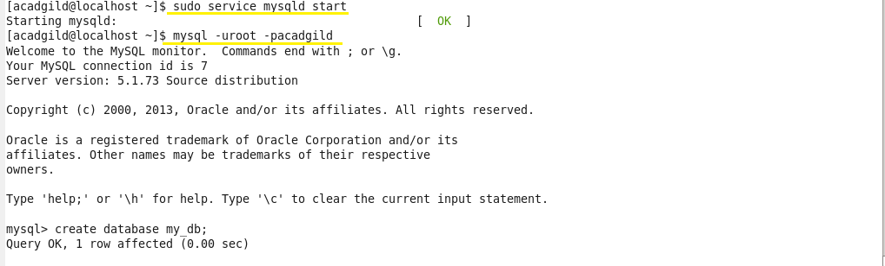

Creating a database by using the **‘create’** command and to work in the created database, we use **‘use’** command.

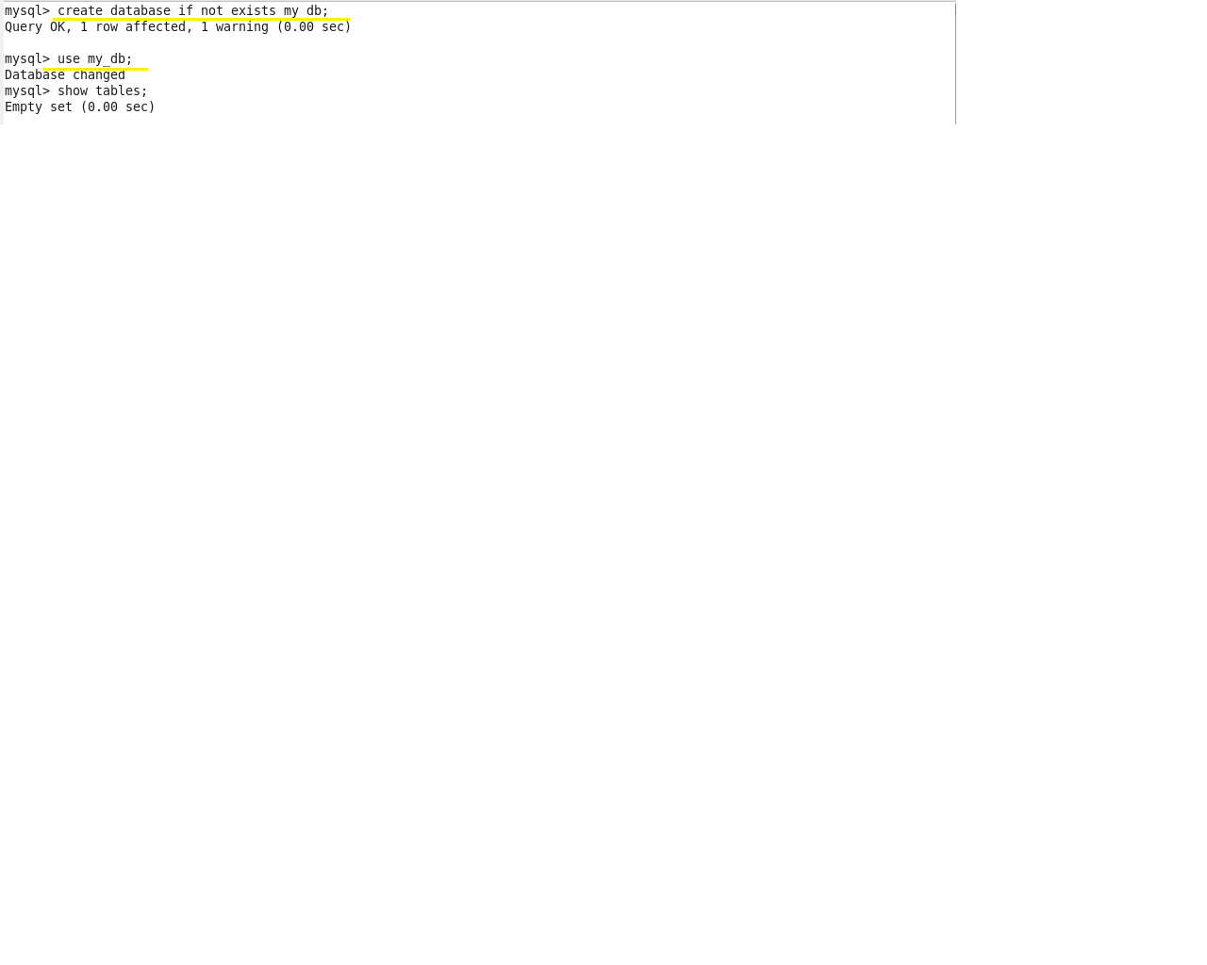

Creating a table **emp** by using the **‘create’** command:

After a table has been created with name **emp** and with the columns id, name, dept, sal. The scheme of this table can be checked using the **‘describe’** command:

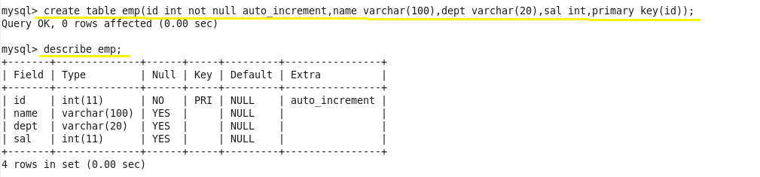

Inserting some sample data into the created table by using **‘insert’** command:

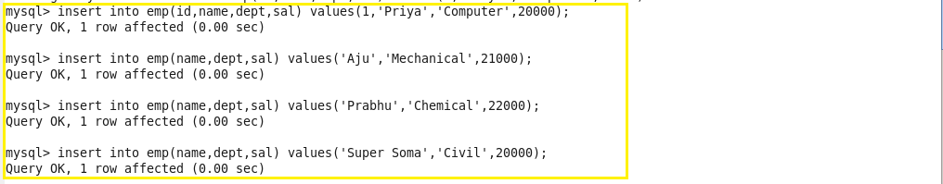

We can check the inserted using this command:

select * from employee;

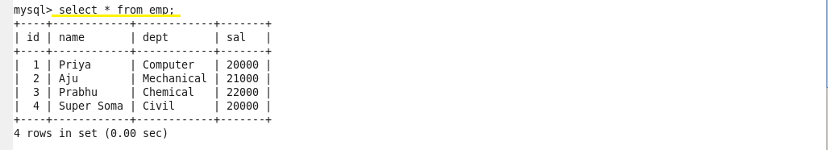

We have successfully created a table in MySQL, and we will now import the same into Hive by using Sqoop.

**Step 2: Importing table contents from MySQL to Hive using Sqoop:**

Below is the command used to import table from MySQL to hive:

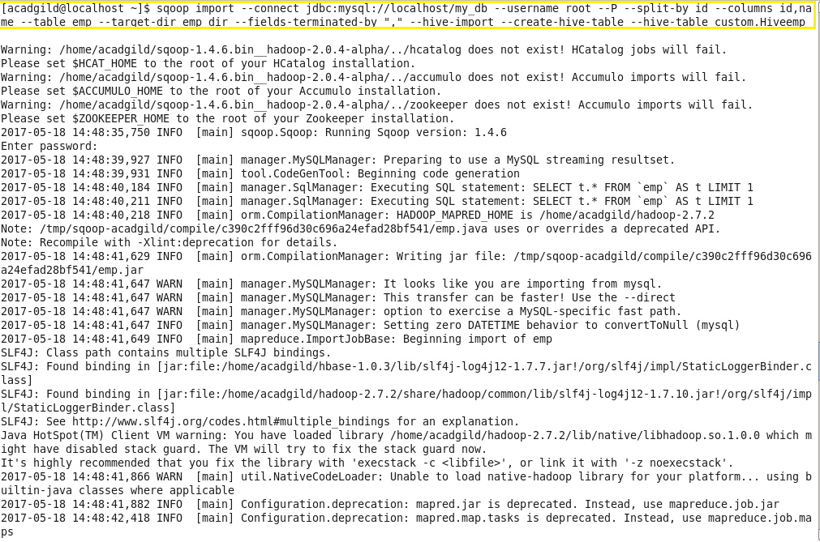

Here’s what each individual Sqoop command option means:

* **connect** – Provides jdbc string
* **username** – Database username
* **-P** – Will ask for the password in console. Alternatively you can use –password but this is not a good practice as its visible in your job execution logs and asking for trouble. One way to deal with this is store database passwords in a file in HDFS and provide at runtime.
* **table**– Tells the computer which table you want to import from MySQL. Here, it's customer.
* **split-by** – Specifies your splitting column. I am specifying id here.
* **target-dir** – HDFS destination directory.
* **fields-terminated-by** – I have specified comma (as by default it will import data into HDFS with comma-separated values)
* **hive-import** – Import table into Hive (Uses Hive’s default delimiters if none are set.)
* **create-hive-table** – Determines if set job will fail if a Hive table already exists. It works in this case.
* **hive-table** – Specifies <db_name>.<table_name>. Here it's sqoop_workspace.customers, where sqoop_workspace is my database and customers is the table name.

As we can see in the image below, all 6 records have been retrieved and the import is now complete.

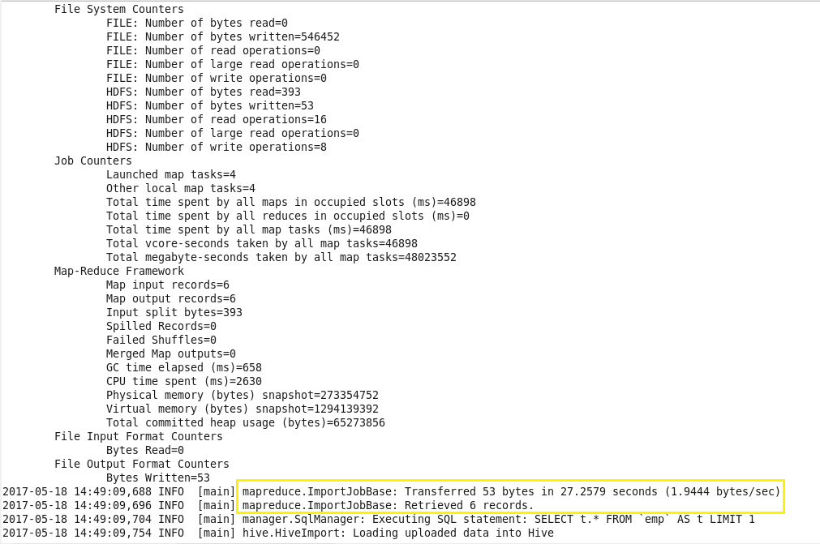

We can see the records in hive.

We start hive using **‘hive’** command.

We can see the tables in the database using **‘show tables’** command.

We can see table **‘hiveemp’** is created in the database **‘custom’**.We can see the contents of table using **‘select’** command.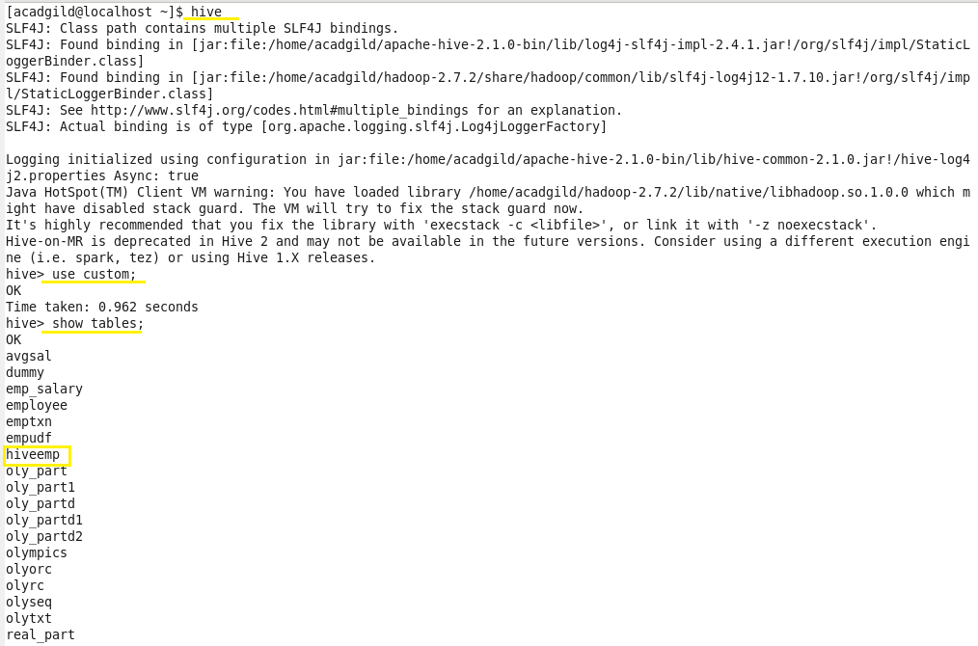

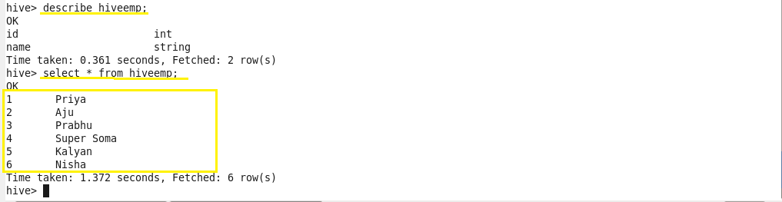

Thus, we have successfully imported contents of MySQL table into hive.

* **Importing table contents from Mysql to HBase using Sqoop:**

**Step 1: Creating table ‘emp’ in MYSQL:**

First we have to login to your MySQL shell.



Creating a database by using the **‘create’** command and to work in the created database, we use **‘use’** command.



Creating a table **emp** by using the **‘create’** command:

After a table has been created with name **emp** and with the columns id, name, dept, sal. The scheme of this table can be checked using the **‘describe’** command:



Inserting some sample data into the created table by using **‘insert’** command:



We can check the inserted using this command: select * from employee



We have successfully created a table in MySQL, and we will now import the same into Hive by using Sqoop.

**Step 2: Creating table in HBase**

First we start the HBase shell using following commands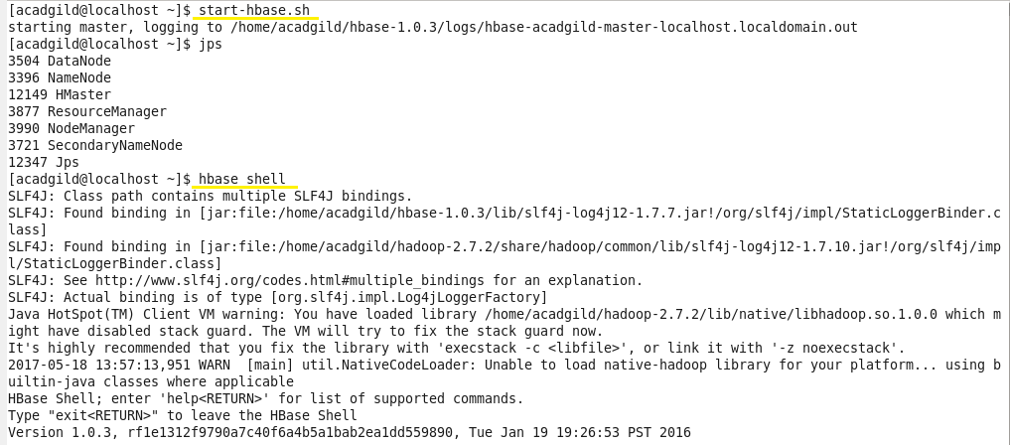

Creating a table in HBase using following syntax. We can see all the contents of the table using ‘scan’ command. Initially the table is empty as no records are inserted.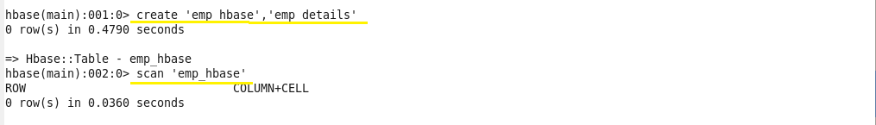

**Step 3: Importing table contents from Mysql to HBase using Sqoop**

Below is the command used to import table from MySQL to HBase:

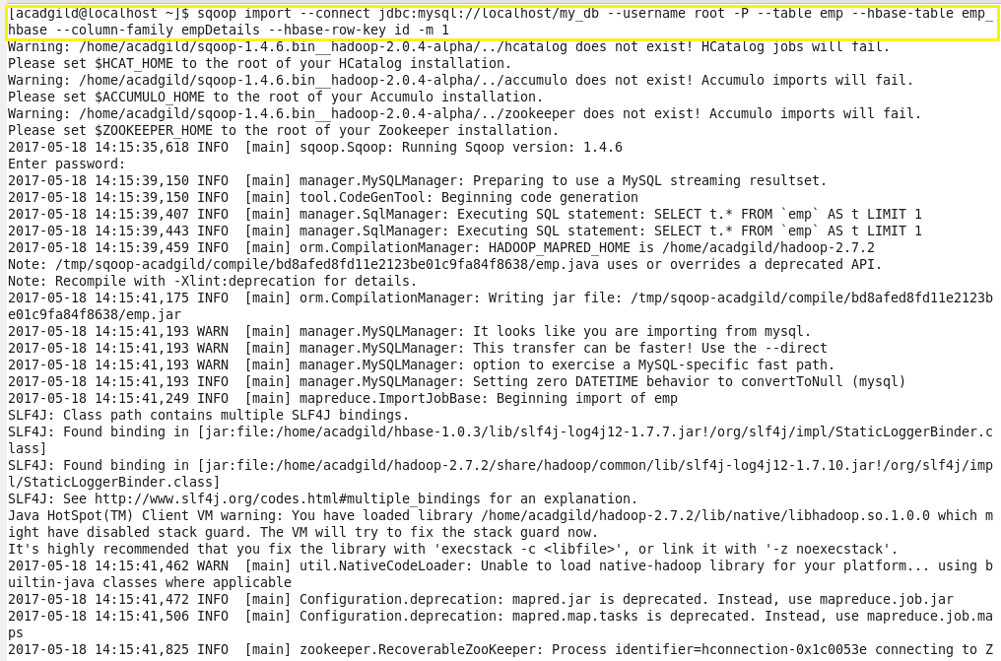

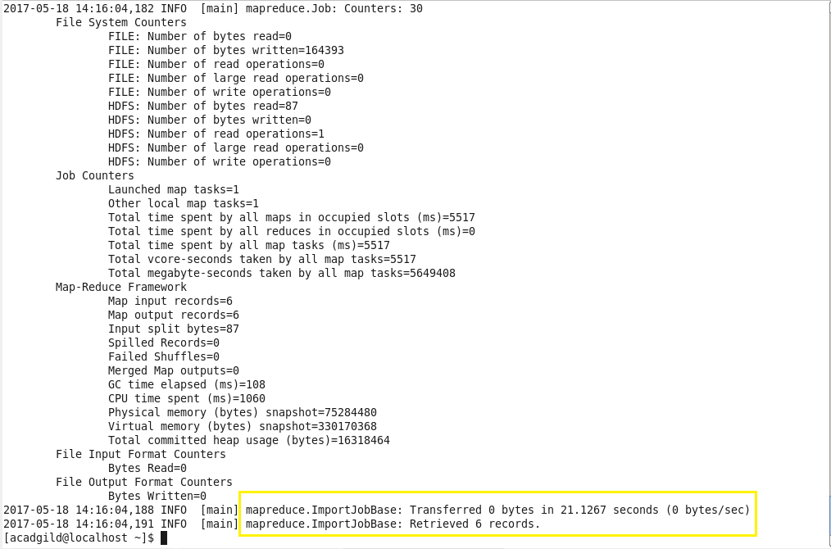

As we can see in above image, all 6 records have been retrieved and the import is now complete.

We can see the contents of imported MySQL table in HBase using ‘scan’ command as below:

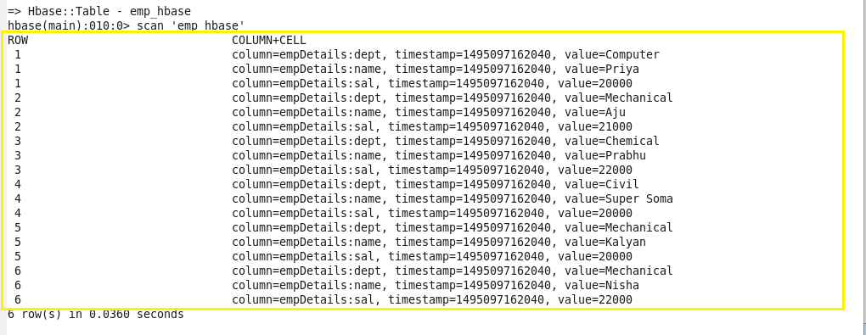

Thus, we successfully imported the contents of MySQL table to HBase using Sqoop.